SINGLE AXIS SOLAR TRACKER USING PIC16F877A

A PROJECT REPORT

submitted by

CB.EN.U4ELC24028 ADHITHYA. R.
CB.EN.U4ELC24029 RAJA THOSHAN
CB.EN.U4ELC24054 HEMANTH. A.K.

CB.EN.U4ELC24020 JAYANTH. M.

in partial fulfillment for the award of the degree

of

BACHELOR OF TECHNOLOGY

IN

ELECTRICAL AND COMPUTER ENGINEERING



AMRITA SCHOOL OF ENGINEERING, COIMBATORE

AMRITA VISHWA VIDYAPEETHAM
COIMBATORE- 641112
March, 2026
ABSTRACT

A solar tracking system is used to improve the efficiency and save the energy of the photovoltaic panels by continuously shifting them towards the direction of maximum sunlight. In this project, a low-level microcontroller-based solar tracking system is designed using the PIC16F877A microcontroller, two Light Dependent Resistors (LDRs) and a servo motor. The LDR sensors detect the light from two different directions in a single axis, and the microcontroller compares the light values through the Analog to Digital Converter (ADC). Based on the difference between the values of the LDR sensors, the microcontroller sends a Pulse Width Modulation signal (PWM) to rotate the servo motor to the brighter light source.

A Timer 1 interrupt routine generates a PWM signal to control the servo motor. Depending on the values received, the servo motor rotates in three different states. If the east LDR receives more light, the servo motor turns to the east side. If the west LDR receives more light, the servo motor turns to the west side. If both the sensors detect nearly equal light intensity, the servo motor adjust back to a neutral central position.

TABLE OF CONTENTS

CHAPTER | TITLE | PAGE  No
1 | INTRODUCTION  - Introduction to Solar Energy  - Need for Solar Tracking Systems  - Problems with Fixed Solar Panels  - Objectives of the Project  - Scope of the Project | 5  5  5  5  5  6
2 | LITERATURE REVIEW  - Overview of Solar Tracking Systems  - Types of Solar Trackers  - Single Axis Tracking  - Dual Axis Tracking  - LDR Based Solar Tracking  - Microcontroller Based Solar Tracking Systems  - Limitations of Existing Systems | 7  7  7  7  7  7  7  8
3 | SYSTEM DESIGN  - System Overview  - Block Diagram of the System  - Working Principle  - Hardware Components  3.4.1 Microcontroller (PIC16F877A)  3.4.2 LDR Sensors  3.4.3 Servo Motor (MG995)  3.4.4 Power Supply Unit  - Circuit Description | 9  9  9  9  10  10  10  10  10  10
4 | SOFTWARE IMPLEMENTATION  4.1 Software Tools Used  4.2 Program Flowchart  4.3 ADC Sensor Reading  4.4 PWM Generation Using Timer 1  4.5 Servo Control Algorithm  4.6 Embedded C Program | 12  12  12  12  13  14  14
5 | RESULTS AND DISCUSSION  5.1 Experimental Setup  5.2 Sensor Reading Analysis  5.3 Servo Motor Response  5.4 Tracking Performance  5.5 Observations | 19  19  19  19  20  20
6 | CONCLUSION AND FUTURE SCOPE  6.1 Conclusion  6.2 Advantage of the System  6.3 Limitations  6.4 Future Scope | 21  21  21  21  21
7 | REFERENCES | 22
8 | MAPPING THE PROJECT WITH POs, PSOs, SDGs | 23

Chapter 1
INTRODUCTION

1.1 Introduction to Solar Energy
Solar energy is a clean and renewable energy source, but fixed solar panels cannot capture maximum sunlight throughout the day due to the sun’s movement. This reduces overall efficiency.
This project presents a microcontroller-based single-axis solar tracking system that uses LDR sensors to detect sunlight intensity and a servo motor to adjust the panel position accordingly. The system automatically aligns the panel toward maximum light, improving energy harvesting efficiency while demonstrating embedded system applications in renewable energy.
1.2 Need for Solar Tracking Systems
Solar panels generate maximum power only when they are directly facing the sun. Since the sun moves from east to west throughout the day, fixed solar panels cannot maintain optimal alignment.

A solar tracking system is needed to automatically adjust the panel position and maximize energy absorption.

1.3 Problems with Fixed Solar Panels
Fixed solar panels are installed at a constant angle, which limits their exposure to sunlight during different times of the day and seasons.

This results in reduced efficiency and lower energy output compared to dynamically oriented systems.

1.4 Objectives of the Project
The main objective of this project is to design and implement a microcontroller-based single-axis solar tracking system.

The system aims to detect light intensity using LDR sensors and automatically adjust the panel position using a servo motor to achieve maximum sunlight exposure.

1.5 Scope of the Project
The project focuses on developing a low-cost and efficient single-axis solar tracking prototype using embedded system techniques.

It demonstrates real-time sensing, control, and actuation, and can be further extended to dual-axis tracking or IoT-based monitoring systems.

Chapter 2
LITERATURE REVIEW

2.1 Overview of Solar Tracking Systems
Solar tracking systems are designed to orient solar panels toward the sun to maximize energy absorption throughout the day.
These systems improve efficiency compared to fixed panels by maintaining optimal alignment with sunlight.
2.2 Types of Solar Trackers
Solar trackers are broadly classified based on their movement capability and control mechanism. The two main types are single-axis and dual-axis trackers.
- 2.2.1 Single Axis Tracking
Single-axis trackers rotate the panel along one axis, typically east to west, following the sun’s daily movement. They are simple, cost-effective, and suitable for moderate efficiency improvement.

- 2.2.2 Dual Axis Tracking
Dual-axis trackers rotate along both horizontal and vertical axes, allowing precise alignment with the sun’s position. They provide higher efficiency but are more complex and expensive.

2.3 LDR Based Solar Tracking
LDR-based systems use light sensors to detect sunlight intensity differences and adjust panel position accordingly. They are simple, low-cost, and suitable for small-scale applications.
2.4 Microcontroller Based Solar Tracking Systems
These systems use microcontrollers to process sensor inputs and control motors accurately. They provide better control, automation, and flexibility.

2.5 Limitations of Existing Systems
Many existing systems face issues such as high cost, mechanical complexity, maintenance requirements, and power consumption, which limit their widespread adoption.

Chapter 3
SYSTEM DESIGN

3.1 System Overview
The proposed system is a microcontroller‑based solar tracking system designed to automatically orient a solar panel toward the direction of maximum sunlight. It uses two LDR sensors to detect light intensity from different directions. The sensor readings are processed by the PIC16F877A, which determines the direction of maximum light and generates control signals to rotate a servo motor. The servo motor adjusts the panel orientation accordingly, ensuring improved solar energy capture.

3.2 System Architecture of the System
The block diagram represents the major functional components of the system and their interaction. It includes the LDR sensors, microcontroller, PWM generation unit, and servo motor that drives the solar panel movement.

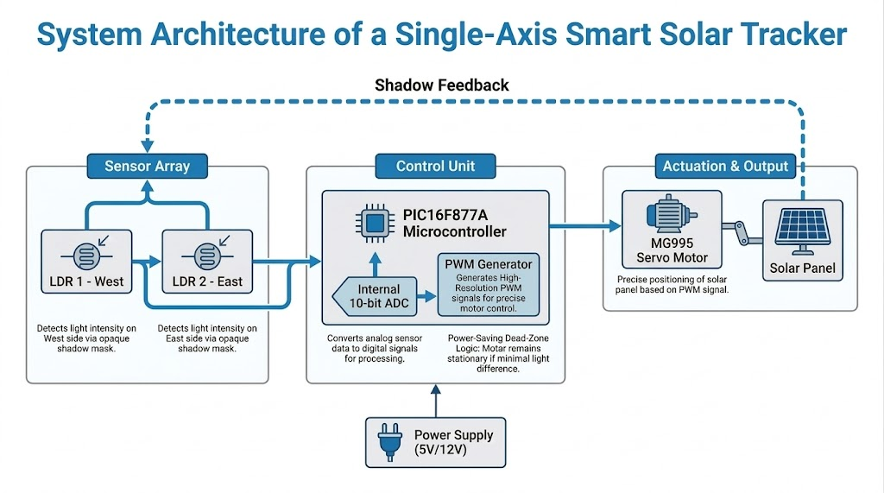
Fig 3.1 System Architecture of a Single-Axis Smart Solar Tracker

3.3 Working Principle
The system operates by continuously monitoring light intensity using two LDR sensors placed on opposite sides of the solar panel. The analog signals from the sensors are converted into digital values using the ADC of the microcontroller. The controller compares the two values and determines which direction receives more sunlight. Based on this comparison, a PWM signal is generated to rotate the servo motor toward the brighter side. When both sensors detect nearly equal light intesity, the panel remains in a neutral position.

3.4 Hardware Components

3.4.1 Microcontroller (PIC16F877A)
The PIC16F877A is the main control unit of the system. It reads analog inputs from the LDR sensors using its built‑in ADC module and processes the data to determine the direction of maximum light. It also generates PWM signals to control the servo motor position.

3.4.2 LDR Sensors
Light Dependent Resistors (LDRs) are used to measure the intensity of sunlight. Their resistance decreases when exposed to higher light levels. Two LDR sensors are placed on opposite sides to detect differences in sunlight intensity.

3.4.3 Servo Motor (MG995)
The MG995 servo motor is used to rotate the solar panel. The motor position is controlled by PWM signals generated by the microcontroller. By adjusting the pulse width, the servo rotates to the desired angle.

3.4.4 Power Supply Unit
A regulated 5V power supply is used to power the microcontroller and sensor modules. The servo motor may require a separate power supply due to its higher current requirement.

3.5 Circuit Description
The circuit consists of two LDR sensors connected to the analog input pins of the microcontroller. The microcontroller reads the sensor outputs using its ADC channels and processes the data to determine the direction of maximum light. The servo motor control signal is generated using PWM on a digital output pin of the microcontroller. The entire system operates on a regulated power supply with a common ground shared between all components.

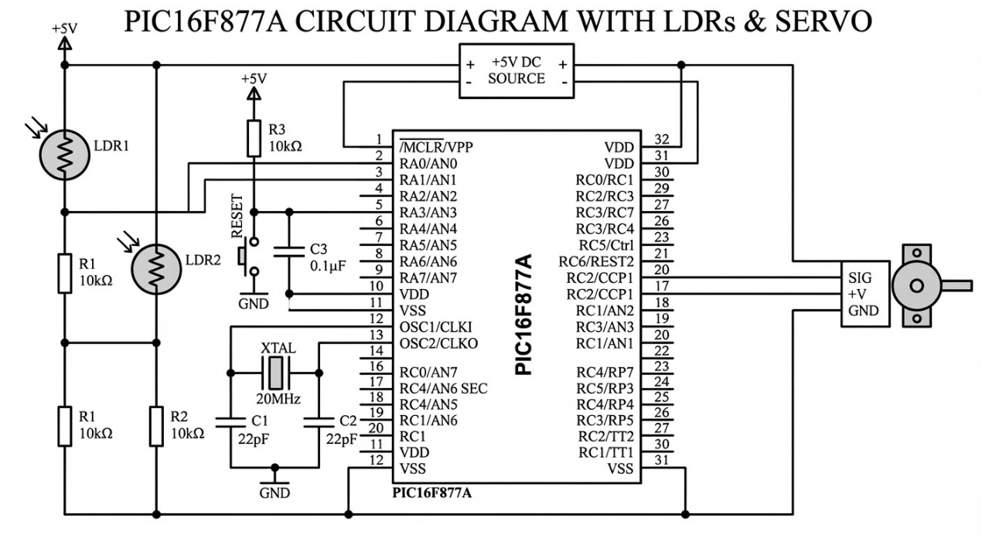Fig 3.2 Circuit Diagram of the Single-Axis Solar Tracking System

Chapter 4
SOFTWARE IMPLEMENTATION

4.1 Software Tools Used
The software development for this project was carried out using MPLAB X IDE and the XC8 compiler, which are commonly used for programming PIC microcontrollers. The program was written in Embedded C and compiled to generate the hexadecimal file required for programming the microcontroller. Simulation and control system analysis were performed using MATLAB/Simulink to model the solar tracking system and study its behavior.

4.2 Program Flowchart
The program flowchart describes the logical sequence followed by the microcontroller during operation. Initially, the microcontroller initializes the ADC module and Timer1 for PWM generation. The system then continuously reads analog values from the two LDR sensors. The microcontroller compares these values to determine the direction of maximum light. Based on this comparison, the controller adjusts the PWM signal to rotate the servo motor either left or right. If the difference between the sensors is within a threshold value, the servo motor returns to the neutral position.
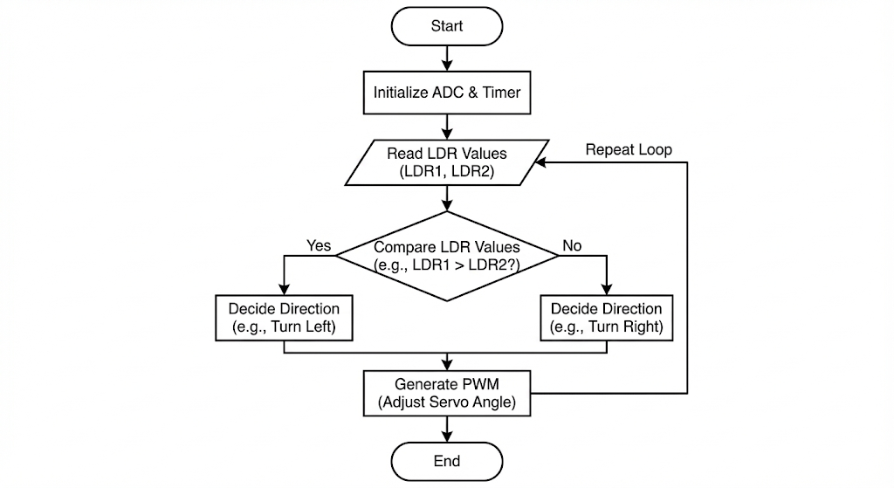Fig 4.1 Flow diagram of the program

4.3 ADC Sensor Reading
The LDR sensors produce analog voltages proportional to light intensity. These signals are connected to the analog input pins of the microcontroller. The internal Analog-to-Digital Converter (ADC) converts these analog signals into digital values that can be processed by the program. The microcontroller periodically reads the sensor values and stores them for comparison.
Code section:
void ADC_Init() {
ADCON1 = 0x80;
ADCON0 = 0x41;
}

4.4 PWM Generation Using Timer1
The servo motor is controlled using Pulse Width Modulation (PWM). Timer1 of the microcontroller is configured to generate precise timing intervals required for servo control. By varying the pulse width of the control signal, the angular position of the servo motor can be adjusted. The PWM signal determines the direction and position of the solar panel.
Code section:
void Timer1_Init() {
T1CON = 0x31; // 1:8 prescaler, Timer1 ON
TMR1IE = 1;
PEIE = 1;
GIE = 1;
}

void __interrupt() ISR() {
if (TMR1IF) {
TMR1IF = 0;
if (state == 0) {
SERVO_PIN = 1;
unsigned int ticks = servo_pulse / 1.6;
TMR1 = 65536 - ticks;
state = 1;
} else {
SERVO_PIN = 0;
unsigned int ticks = (20000 - servo_pulse) / 1.6;
TMR1 = 65536 - ticks;
state = 0;
}
}
}

4.5 Servo Control Algorithm
The servo control algorithm determines how the panel moves based on the sensor readings. The system calculates the difference between the two LDR values. If the east sensor detects higher light intensity, the servo rotates toward the east. If the west sensor detects higher light intensity, the servo rotates toward the west. When the difference between the sensor readings is within a predefined threshold, the servo motor moves gradually toward a neutral position.

4.6 Embedded C Program
The complete program is written in Embedded C and includes initialization routines, ADC reading functions, PWM generation using Timer1, and the main control logic. The program continuously monitors the sensor values and adjusts the servo motor position to maintain optimal alignment with the light source.
Code section:
#include <xc.h>
#pragma config FOSC = HS, WDTE = OFF, PWRTE = ON, BOREN = ON, LVP = OFF

#define _XTAL_FREQ 20000000

#define SERVO_PIN RC2

#define THRESHOLD 60 // Difference to trigger tracking
#define NEUTRAL_PULSE 1450 // Center position (90°)
#define SERVO_MIN_PULSE 800 // 0° limit
#define SERVO_MAX_PULSE 2200 // 180° limit
#define STEP 10 // Pulse change per loop iteration
#define NEUTRAL_STEP 10

volatile unsigned int servo_pulse = NEUTRAL_PULSE;
volatile unsigned char state = 0;

// ===================== ADC =====================
void ADC_Init() {
ADCON1 = 0x80;
ADCON0 = 0x41;
}

unsigned int ADC_Read(unsigned char channel) {
ADCON0 &= 0xC7;
ADCON0 |= (channel << 3);
__delay_us(30);
GO_nDONE = 1;
while (GO_nDONE);
return ((unsigned int)ADRESH << 8) | ADRESL;
}

// TIMER1 ISR (Servo PWM)
void Timer1_Init() {
T1CON = 0x31; // 1:8 prescaler, Timer1 ON
TMR1IE = 1;
PEIE = 1;
GIE = 1;
}

void __interrupt() ISR() {
if (TMR1IF) {
TMR1IF = 0;
if (state == 0) {
SERVO_PIN = 1;
unsigned int ticks = servo_pulse / 1.6;
TMR1 = 65536 - ticks;
state = 1;
} else {
SERVO_PIN = 0;
unsigned int ticks = (20000 - servo_pulse) / 1.6;
TMR1 = 65536 - ticks;
state = 0;
}
}
}

// ===================== MAIN =====================
void main() {
TRISA = 0x03;
TRISC2 = 0;
SERVO_PIN = 0;

ADC_Init();
Timer1_Init();

while (1) {
unsigned int east = ADC_Read(0);
unsigned int west = ADC_Read(1);

int diff = (int)east - (int)west;

// ---- STATE 1: East is brighter ? track east ----
if (diff > THRESHOLD) {
if (servo_pulse > SERVO_MIN_PULSE)
servo_pulse -= STEP;
}

// ---- STATE 2: West is brighter ? track west ----
else if (diff < -THRESHOLD) {
if (servo_pulse < SERVO_MAX_PULSE)
servo_pulse += STEP;
}

// ---- STATE 3: Light is balanced ? return to neutral ----
else {
// Gradually ease back to center instead of snapping
if (servo_pulse < NEUTRAL_PULSE - NEUTRAL_STEP) {
servo_pulse += NEUTRAL_STEP;
}
else if (servo_pulse > NEUTRAL_PULSE + NEUTRAL_STEP) {
servo_pulse -= NEUTRAL_STEP;
}
else {
servo_pulse = NEUTRAL_PULSE; // Lock to exact center
}
}

__delay_ms(20);
}
}

Chapter 5

RESULTS AND DISCUSSION

5.1 Experimental Setup
The experimental setup consisted of two LDR sensors placed on opposite sides of a small solar panel to detect sunlight intensity. The sensors were connected to the analog input pins of the PIC16F877A, which processed the sensor readings using its internal ADC module. A MG995 servo motor was used to rotate the panel based on the control signals generated by the microcontroller. The system was powered using a regulated 5V supply, and the servo motor was connected to a PWM output pin of the controller.
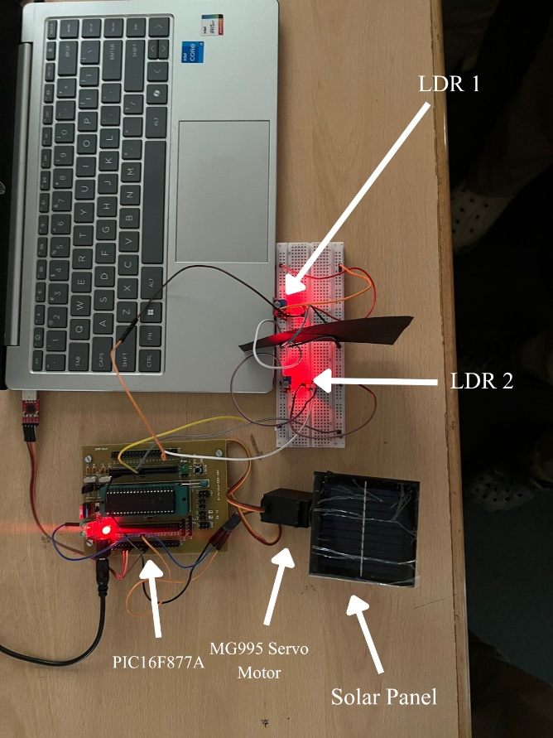
Fig 5.1 Experimental Hardware Setup of the Single-Axis Solar Tracker

5.2 Sensor Reading Analysis
During testing, the microcontroller continuously read analog values from both LDR sensors. When one sensor received more light than the other, a noticeable difference was observed in the ADC values. This difference was used by the controller to determine the direction of maximum sunlight. The readings confirmed that the sensors effectively detected variations in light intensity.

5.3 Servo Motor Response
The servo motor responded to the PWM signals generated by the microcontroller. When the light intensity difference exceeded the defined threshold, the servo rotated toward the brighter sensor. The movement of the servo was smooth and gradual due to controlled pulse width adjustments.

5.4 Tracking Performance
The system successfully tracked the direction of maximum light by adjusting the panel orientation. As the light source moved, the servo motor repositioned the panel accordingly. The tracking mechanism improved the panel’s alignment with the light source compared to a fixed position.

5.5 Observations
The system demonstrated reliable operation under varying light conditions. The LDR sensors effectively detected changes in light intensity, and the microcontroller accurately controlled the servo motor. The experiment confirmed that a microcontroller‑based solar tracking system can enhance solar panel alignment and improve energy collection efficiency.

Chapter 6

CONCLUSION AND FUTURE SCOPE

6.1 Conclusion
The project successfully demonstrates a microcontroller‑based solar tracking system that automatically aligns a solar panel toward the direction of maximum sunlight. By using LDR sensors to detect light intensity and a PIC16F877A to process sensor inputs, the system controls a servo motor to adjust the panel orientation. The implementation shows how embedded systems can improve solar energy utilization through automatic tracking and efficient control.

6.2 Advantages of the System
The proposed system is simple, cost‑effective, and easy to implement using commonly available components. It improves the efficiency of solar panels by maintaining proper alignment with sunlight. The use of a microcontroller allows accurate control, automation, and flexibility for further improvements.

6.3 Limitations
The system tracks sunlight only along a single axis, which limits its ability to achieve maximum alignment throughout the entire day and across different seasons. The accuracy of tracking also depends on the placement and sensitivity of the LDR sensors. Additionally, the servo motor requires sufficient power supply to operate reliably.

6.4 Future Scope
The project can be extended by implementing a dual‑axis tracking system for improved solar alignment. Additional features such as wireless monitoring, IoT‑based data logging, and integration with larger photovoltaic systems can also be incorporated to enhance performance and functionality.

REFERENCES

[1] Mehdi, G., Ali, N., Hussain, S., Zaidi, A. A., Shah, A. H., & Azeem, M. M. (2019, January). Design and fabrication of automatic single axis solar tracker for solar panel. In 2019 2nd International Conference on Computing, Mathematics and Engineering Technologies (iCoMET) (pp. 1-4). IEEE.

[2] Kuttybay, N., Saymbetov, A., Mekhilef, S., Nurgaliyev, M., Tukymbekov, D., Dosymbetova, G., ... & Svanbayev, Y. (2020). Optimized single-axis schedule solar tracker in different weather conditions. Energies, 13(19), 5226.

[3] Sallaberry, F., Pujol-Nadal, R., Larcher, M., & Rittmann-Frank, M. H. (2015). Direct tracking error characterization on a single-axis solar tracker. Energy Conversion and Management, 105, 1281-1290.

[4] Rani, P., Singh, O., & Pandey, S. (2018, November). An analysis on arduino based single axis solar tracker. In 2018 5th IEEE Uttar Pradesh Section International Conference on Electrical, Electronics and Computer Engineering (UPCON) (pp. 1-5). IEEE.

[5] Ponniran, A., Hashim, A., & Joret, A. (2011). A design of low power single axis solar tracking system regardless of motor speed. International Journal of Integrated Engineering, 3(2).

Mapping the project with POs, PSOs, and SDGs

PO mapping: PO1 – Engineering Knowledge
PO2 – Problem Analysis
PO3 – Design/Development of Solutions
PO4 – Conduct Investigations of Complex Problems
PO5 – Engineering Tool Usage
PO9 – Communication

PSO mapping: PSO1 – Autonomous Systems Development
PSO3 – Sustainable Solutions

SDGs | Justification to the Contribution
SDG-7 | The system tracks sunlight automatically to maximize solar panel exposure. This improves renewable energy efficiency and promotes clean power generation.
SDG-9 | The project integrates sensors, microcontroller processing, and servo actuation to create an automated solar tracking system. It demonstrates innovation in embedded energy technologies.
SDG-13 | Efficient solar energy utilization reduces reliance on fossil fuels. This supports efforts to lower greenhouse gas emissions and mitigate climate change.



